



Basavarajeswari group of institutions

BALLARI INSTITUTE OF TECHNOLOGY & MANAGEMENT
NACC Accredited Institution*
(Recognized by Govt. of Karnataka, approved by AICTE, New Delhi & Affiliated to Visvesvaraya Technological University, Belagavi)
"JnanaGangotri" Campus, No.873/2, Ballari-Hospet Road, Allipur, Ballar1-583 104 (Karnataka) (India)
Ph: 08392 – 237100 / 237190, Fax: 08392 – 237197

DEPARTMENT OF CSE(DATA SCIENCE)

A Mini-Project Report On

“ ADIDAS SALES ANALYSIS VISUALIZATION ”

A report submitted in partial fulfillment of the requirements for the

DATA VISUALIZATION WITH POWER BI

Submitted By

SHIVAMANI B USN: 3BR23CD089
Under the Guidance of Mr.Sundeep Sindhanoor Asst. Professor
Dept of CSE (DATA SCIENCE),
BITM, Ballari

Visvesvaraya Technological University

Belagavi, Karnataka 2025-2026





BASAVARAJESWARI GROUP OF INSTITUTIONS
BALLARI INSTITUTE OF TECHNOLOGY & MANAGEMENT
NACC Accredited Institution*
(Recognized by Govt. of Karnataka, approved by AICTE, New Delhi & Affiliated to Visvesvaraya Technological University, Belagavi)

"JnanaGangotri" Campus, No.873/2, Ballari-Hospet Road, Allipur, Ballari-583 104 (Karnataka) (India)
Ph: 08392 – 237100 / 237190, Fax: 08392 – 237197

DEPARTMENT OF CSE (DATA SCIENCE)

This is to certify that the OPEN-ENDED PROJECT of DATA VISUALIZATION WITH POWER BI “ADIDAS SALES ANALYSIS VISUALIZATION” has been successfully presented by SHIVAMANI B bearing USN 3BR23CD089 student of semester B.E for the partial fulfillment of the requirements for the award of Bachelor Degree in CSE(DS) of the BALLARI INSTITUTE OF TECHNOLOGY& MANAGEMENT, BALLARI during the academic year 2025-2026.

Signature of guide Signature of HOD

Mr. Sundeep Sindhanoor Dr. Aradhana D

The satisfactions that accompany the successful completion of our mini project on “ADIDAS SALES ANALYSIS VISUALIZATION” would be incomplete without the mention of people who made it possible, whose noble gesture, affection, guidance, encouragement and support crowned my efforts with success. It is our privilege to express our gratitude and respect to all those who inspired us in the completion of our mini-project. We are extremely grateful to our Guides Mr.Sundeep Sindhanoor for their noble gesture, support co-ordination and valuable suggestions given in completing the mini-project. We also thank Dr. Aradhana D, H.O.D. Department of CSE(DS), for his co-ordination and valuable suggestions given in completing the mini-project. We also thank the Principal, Management and non-teaching staff for their co-ordination and valuable suggestions given to us in completing the project.

NAME USN

SHIVAMANI B
3BR23CD089

Table of Contents
Ch No | Chapter Name | Page
1 | Introduction  - About the project  - Language used | 1-2
2 | Scope of the project  - Problem statement  - Objectives | 3-4
3 | System requirements  - Functional Requirements  - Non-Functional Requirements  - Hardware Requirements  - Software Requirements | 5-6
4 | Methodology  - Data Collection  - Data Preparation(Power Query)  - Data Visualization  - Filters and Interactivity  - Dashboard Design  - outcome | 7-8

5 | Implementation  - Dataset Description  - Data Loading  - Data Transformation(Power Query)  - Data Modelling  - DAX Measures(Key Calculations)  - Dashboard Visualization  - Filters / Slicers  - Dashboard Layout  - Integration  - Final output | 9-11
6 | Result | 12-13
 | Conclusion | 14
 | References | 15

ABSTRACT

This project presents an interactive Adidas Sales Analysis dashboard developed using Power BI to deliver comprehensive insights into retail sales performance, regional trends, and product profitability. The dashboard consolidates transactional sales data, retailer records, regional breakdowns, and product category metrics to visualize key performance indicators such as total sales revenue, units sold, operating profit, average price per unit, and operating margin.
The system highlights top-performing retailers and product categories through performance metrics such as total revenue, operating profit, and regional sales distribution. It also provides month-wise and state-wise comparative views for strategic business decision-making. By integrating multiple data sources and applying data modelling, DAX calculations, and interactive visuals, the dashboard enables business analysts, sales managers, and executives to explore trends, compare regional performances, and gain actionable insights in an intuitive and user-friendly manner.

.

CHAPTER 1

INTRODUCTION

About the Project

This project involves the design and development of a Power BI dashboard that provides a comprehensive analysis of Adidas sales data across multiple regions, product categories, and retail channels. It encompasses key performance indicators such as total units sold (2M), total sales revenue ($899M), total operating profit ($332M), average price per unit ($45), and overall operating margin (42%).
The dashboard highlights:
- Total sales performance using KPI cards displaying revenue, profit, units sold, and margin figures at a glance
- Monthly sales trends visualized through a line chart spanning January to December, revealing seasonal patterns and peak performance months
- Regional sales distribution using a donut chart across five regions: West (20.63%), Midwest (18.15%), Southeast (16.09%), South (15.1%), and Northeast (30.03%)
- State-level performance displayed through an interactive choropleth map of the United States
- Product category breakdown via horizontal bar charts showing Men's Street Footwear ($208M) as the top category, followed by Women's Apparel ($179M)
- Retailer-wise performance comparison highlighting West Gear ($243M), Foot Locker ($219M), and Sports Direct ($182M) as top contributors
- Date range and region-based filtering for targeted business review and period-specific analysis
By leveraging Power BI features such as data modelling, DAX calculations, and interactive slicers, the project provides a user-friendly interface for deep data exploration and evidence-based sales decision-making for executives, regional managers, and retail analysts.

Language Used

The primary tools and languages used in this project include:
- Power BI Desktop – for data visualization and interactive dashboard creation featuring maps, charts, KPI cards, and slicers
- DAX (Data Analysis Expressions) – for creating calculated measures and KPIs such as Operating Margin, Total Revenue, and Operating Profit calculations
- Power Query (M Language) – for data cleaning, transformation, and preprocessing of Adidas sales transaction records
- Data Sources – structured datasets (CSV/Excel) containing Adidas retail sales records including invoice dates, region codes, retailer names, product categories, units sold, and pricing information
These technologies work together to transform raw Adidas sales data into meaningful visual insights, ensuring accuracy, interactivity, and efficiency in performance analysis across all business dimensions.

CHAPTER 2

  - Problem Statement

SCOPE OF THE PROJECT

Retail organizations like Adidas generate enormous volumes of transactional sales data every month across various regions, product lines, and retail partners. However, this data is often fragmented, unstructured, and difficult to interpret without proper analytical tools.

Key problems addressed in this project include:

- Data Overload: Large datasets spread across multiple retailers, regions, and product categories make it challenging to extract meaningful insights manually

- Lack of Centralized Visualization: Sales information is scattered across spreadsheets, internal portals, and retail reports, making comparison and analysis inefficient

- Difficulty in Performance Comparison: Comparing regional sales, retailer contributions, and product performance across months requires complex manual calculations and data aggregation

- Limited Insight into Trends: Without proper visualization, identifying trends such as seasonal peaks, low-margin products, or underperforming regions is difficult

- Inefficient Decision Support: Sales managers and executives lack a simplified tool to quickly interpret business data for strategic planning or resource allocation

This project aims to solve these challenges by creating a centralized, interactive, and visually rich sales dashboard that simplifies data interpretation and enhances analytical capabilities for all stakeholders.

Objectives

The primary objective of this project is to design and implement an efficient Adidas Sales Analysis system that transforms raw retail transaction data into meaningful insights using Power BI.
Core Objectives:
- To develop an interactive dashboard that provides a complete overview of Adidas sales statistics across regions, retailers, and product categories
- To analyze sales performance based on total revenue, operating profit, units sold, average price per unit, and operating margin percentage
- To identify top-performing retailers and product categories using metrics such as total sales figures and operating profit contributions
- To visualize monthly and regional sales trends using key indicators like revenue growth patterns and geographic distribution maps
- To enable region-based and date-range filtering for detailed analysis of specific time periods and geographic markets
- To create a dynamic performance summary for comparing sales standings across retailers and product categories

CHAPTER 3
SYSTEM REQUIREMENTS

Functional Requirements
- Data Loading: Import Adidas sales transaction data from CSV/Excel and support periodic data refresh with updated invoice records
- Data Processing: Clean, transform, and model data using Power Query Editor
- Visualization: KPIs like total units sold (2M), total sales ($899M), operating profit ($332M), average price per unit ($45), and operating margin (42%)
- Sales Analysis: Show monthly revenue trends, regional breakdowns, and product category rankings through interactive charts
- Regional Analysis: Provide state-level choropleth map and regional donut chart
- Filtering: Enable region and invoice date range filtering using slicers for targeted
- Interactivity: Support drill-down, tooltips, and cross-filtering between visuals
- Insights: Generate statistical summaries and sales performance trend reports
- Usability: Ensure fast performance and an easy-to-navigate user interface
- Export: Allow report and visual export for sharing with sales leadership

Non-Functional Requirements
- Performance: Dashboard should load quickly and handle large adidas transaction datasets efficiently
- Scalability: System should support addition of new sales periods, product categories, and retail partners without performance degradation
- Usability: Interface must be simple, interactive, and easy to understand for all users including sales manager and business analyst
- Reliability: Data calculations and visuals should be accurate and consistent at all times
- Availability: Dashboard should be accessible whenever required without failures
- Maintainability: Easy to update datasets, modify visuals, and extend features for new sales years
- Security: Ensure data integrity and restrict unauthorized access to sensitive sales information
- Compatibility: Should work across different devices and screen sizes (desktop/laptop)
- Flexibility: Support customization like filters, slicers, and user-driven sales analysis
- Data Quality: Ensure clean, validated, and well-structured data for accurate sales insights

Hardware Requirements

- Operating System: Windows 10, Windows 11, or Windows Server 2016/2019/2022
- Processor (CPU): 1.4 GHz 64-bit (x64) processor or better
- Memory (RAM): 4 GB RAM (8 GB recommended for large Adidas multi-year sales datasets)
- Storage: 2 GB of available hard disk space for the Power BI Desktop application and data cache
- Display: 1440 x 900 or 1600 x 900 (16:9) resolution for optimal dashboard viewing

Software Requirements

- Development: Microsoft Power BI Desktop (requires Windows 10/11) for dashboard design and data modelling
- Data Source: CSV/Excel files containing Adidas sales transaction records, retailer data, and product category details
- Deployment & Hosting: Power BI Service (cloud platform for publishing and sharing the interactive Adidas sales dashboard)
- End-User Access: Any modern web browser (Google Chrome, Microsoft Edge, Safari) or the Power BI Mobile App (iOS/Android) for viewing the sales report

CHAPTER 4
METHODOLOGY

The methodology of this project follows a structured data analytics pipeline, transforming raw Adidas retail sales transaction data into meaningful visual insights using Power BI.
4.1 Data Collection
- Adidas retail sales datasets were collected covering transactions from February 2020 to December 2021 across all US regions
- Data includes invoice records, retailer names, regional information, product categories, units sold, price per unit, total sales, and operating profit
4.2 Data Preprocessing
- Cleaned the data using Power Query (M Language)
- Handled missing values, duplicates, and inconsistencies in retailer and sales records
- Standardized formats for invoice dates, region codes, state names, and product category labels
4.3 Data Modelling
- Established relationships between tables (sales transactions, retailers, products, regions)
- Created a star schema model for efficient querying and report generation
- Ensured proper data structure for cross-regional and cross-category analysis
4.4 DAX Calculations
- Developed measures and calculated columns using DAX
- Examples include: Total Sales Revenue, Sum of Units Sold, Sum of Operating Profit, Average Price per Unit, Operating Margin Percentage, Monthly Sales Aggregation

4.5. Dashboard Design
- DDesigned an interactive Power BI dashboard with KPI Cards, Line Charts, Donut Charts, Bar Charts, a US Choropleth Map, and Slicers

4.6 Data Visualization
- Represented insights like monthly revenue trends, state-level sales distribution, retailer rankings, and product category performance
- Enabled interactive filtering and cross-filtering features for granular business analysis

4.7 Testing and Validation
- Verified accuracy of all financial calculations and visual representations
- Ensured dashboard responds correctly to all regional filters and date range selections

4.8 Deployment
- Final dashboard published using Power BI Service/Desktop
- Ready for sharing and presentation to sales leadership and retail business stakeholders

CHAPTER 5
IMPLEMENTATION

The implementation phase focuses on converting the designed methodology into a working Power BI dashboard by integrating Adidas sales retail data, applying transformations, and building interactive visualizations.

5.1 Dataset Description
- Sales Transactions Table: Invoice Date, Retailer Name, Region, State, City, Product Category, Price per Unit, Units Sold, Total Sales, Operating Profit, Operating Margin
- Retailers Table: Retailer ID, Retailer Name, Channel Type, Total Revenue Contribution
- Products Table: Product Category (Men's Street Footwear, Women's Apparel, Men's Athletic, Women's Street, Men's Apparel, Women's Athletic), Category Sales
- Regions Table: Region Name (West, Northeast, Southeast, South, Midwest), State Mapping, Regional Sales Totals

5.2 Data Loading
- Adidas sales datasets (CSV/Excel) covering Feb 2020 – Dec 2021 were imported into Power BI Desktop
- Multiple tables such as sales transactions, retailer data, product categories, and regional mapping were loaded
- Data source connections were configured for seamless refresh with updated transaction records

5.3 Data Transformation (Power Query)
- Used Power Query Editor to clean and prepare raw Adidas sales data
- Removed duplicate transaction entries and handled missing sales values
- Corrected data types for numeric fields (price per unit, units sold, operating profit, margin)
- Filtered irrelevant columns and standardized product category labels and region codes

5.4 Data Modelling
- Created relationships between tables (Invoice Date, Retailer ID, Product Category, Region)
- Designed a star schema for efficient querying and performance optimization across all visuals
- Ensured proper linkage for accurate cross-filtering across all map, chart, and card components

5.5 DAX Measures (Key Calculations)
- Implemented key business metrics using DAX (Data Analysis Expressions):
- Total Units Sold = SUM(Sales[Units_Sold]) → Result: 2M units
- Total Sales Revenue = SUM(Sales[Total_Sales]) → Result: $899M
- Sum of Operating Profit = SUM(Sales[Operating_Profit]) → Result: $332M
- Average Price per Unit = AVERAGE(Sales[Price_per_Unit]) → Result: $45
- Operating Margin = DIVIDE(SUM(Sales[Operating_Profit]), SUM(Sales[Total_Sales])) * 100 → Result: 42%
- Monthly Sales = CALCULATE(SUM(Sales[Total_Sales]), DATESMTD(Calendar[Date]))
- RetailerShare=DIVIDE(SUM(Sales[Total_Sales]), CALCULATE(SUM(Sales[Total_Sales]), ALL(Sales[Retailer])))

5.6 Dashboard Visualization
- KPI Cards: Sum of Units Sold (2M), Sum of Operating Profit ($332M), Sum of Total Sales ($899M), Average Price per Unit ($45), Operating Margin (42%)
- Line Chart: Total Sales by Month showing monthly trends from January ($61M) through December ($86M), with peak in July ($95M)
- Choropleth Map: Total Sales by State visualizing geographic sales distribution across all US states using colour intensity
- Donut Chart: Total Sales by Region displaying West (20.63%), Northeast (30.03%), Southeast (16.09%), South (15.1%), and Midwest (18.15%)
- Horizontal Bar Charts: Total Sales by Product showing Men's Street Footwear ($208M) at the top, and Total Sales by Retailer showing West Gear ($243M) and Foot Locker ($219M) as leaders

5.7 Filters / Slicers
- Added Region slicer with "All" option for nationwide or region-specific performance views
- Invoice Date range filter for period-specific analysis from 02-01-2020 to 31-12-2021
- Enabled cross-filtering between all visuals including map, charts, and KPI cards for seamless exploration

5.8 Dashboard Layout
- Clean, colour-coded interface with Adidas brand-aligned navy blue header and white KPI cards
- Five KPI cards at the top for at-a-glance summary metrics covering sales, profit, units, price, and margin
- Line chart and choropleth map positioned centrally for trend and geographic analysis
- Donut chart and dual bar charts arranged in the bottom section for product and retailer analysis

5.9 Integration
- All data tables integrated through established model relationships across regions, products, and retailers
- Region slicer and date range filter connected to all visuals for synchronized interactivity
- Tooltips configured to show additional context on hover for all chart elements

5.10 Final Output
- Fully functional interactive Adidas Sales Analysis dashboard covering US retail performance from 2020–2021
- Supports region-wise, retailer-wise, product-wise, and month-wise business analysis
- Ready for deployment via Power BI Service for executive and managerial access
- Exportable as PDF or PowerPoint for presentation and business reporting
CHAPTER 6
RESULT
The implementation of the Adidas Sales Analysis Dashboard using Power BI resulted in a comprehensive, interactive, and data-driven visualization system that effectively transforms large volumes of raw retail transaction data into meaningful and actionable business insights. The final dashboard provides a centralized platform where sales managers, regional executives, and business analysts can explore, analyze, and interpret Adidas sales performance statistics with ease and clarity.
One of the key outcomes of this project is the successful visualization of core business performance metrics. As reflected in the dashboard, Adidas recorded total units sold of 2 million, total sales revenue of $899 million, operating profit of $332 million, an average price per unit of $45, and an overall operating margin of 42%. These KPI cards presented at the top of the dashboard allow users to instantly assess the overall financial health of Adidas retail operations without any manual calculation.
The monthly sales trend analysis reveals significant seasonal patterns in Adidas revenue. The line chart spanning the entire year clearly shows that sales were lowest in January ($61M) with a gradual rise reaching a peak in July ($95M), followed by a slight mid-year dip in August ($64M) and October ($68M), before recovering towards year-end in December ($86M). This insight is critical for inventory planning, promotional campaign scheduling, and supply chain optimization.
The geographic analysis through the US choropleth map provides state-level visibility into sales concentration. Darker-shaded states in the Northeast and Southeast regions indicate higher sales volumes, while lighter regions highlight areas with growth potential. This map visualization enables regional managers to identify underperforming markets and allocate resources accordingly.
The regional donut chart further confirms the Northeast region as the highest contributor with 30.03% ($270M) of total sales, followed by the West at 20.63% ($185M), Midwest at 18.15% ($163M), Southeast at 16.09% ($145M), and South at 15.1% ($136M). This distribution indicates both market concentration and expansion opportunities in the Southern and Southeastern regions.
Product category performance analysis reveals that Men's Street Footwear dominates with $208M in sales, closely followed by Women's Apparel at $179M and Men's Athletic Footwear at $154M. Women's Street Footwear ($128M), Men's Apparel ($124M), and Women's Athletic Footwear ($107M) complete the portfolio. This data empowers the product management team to prioritize high-performing categories and develop targeted promotional strategies for mid-performing segments.
The retailer performance analysis highlights West Gear as the top-performing retailer with $243M in total sales, followed by Foot Locker at $219M and Sports Direct at $182M. Mid-tier retailers include Kohl's ($102M), Amazon ($78M), and Walmart ($75M). These insights assist in strategic partnership decisions and help evaluate the ROI of different retail channel investments.
The integration of interactive features greatly enhances the usability of the system. Users can apply region filters and select custom date ranges, with all visuals updating dynamically in real time. Cross-filtering between the map, bar charts, donut chart, and line chart enables deeper and contextual exploration of sales data. From a technical perspective, the effective use of Power Query, data modelling, and DAX ensures accuracy, consistency, and performance efficiency throughout the dashboard.

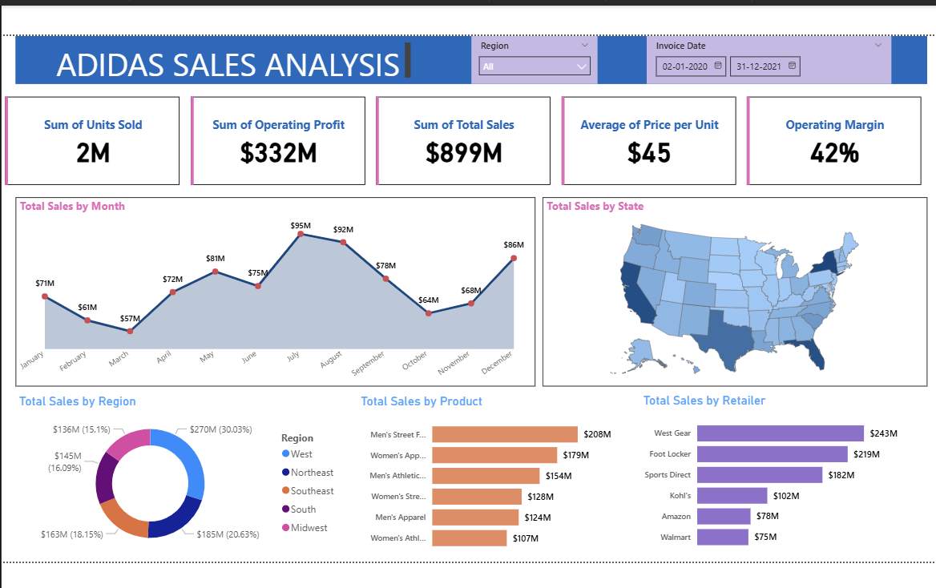

Fig 1 : ADIDAS SALES ANALYSIS PERFORMANCE.

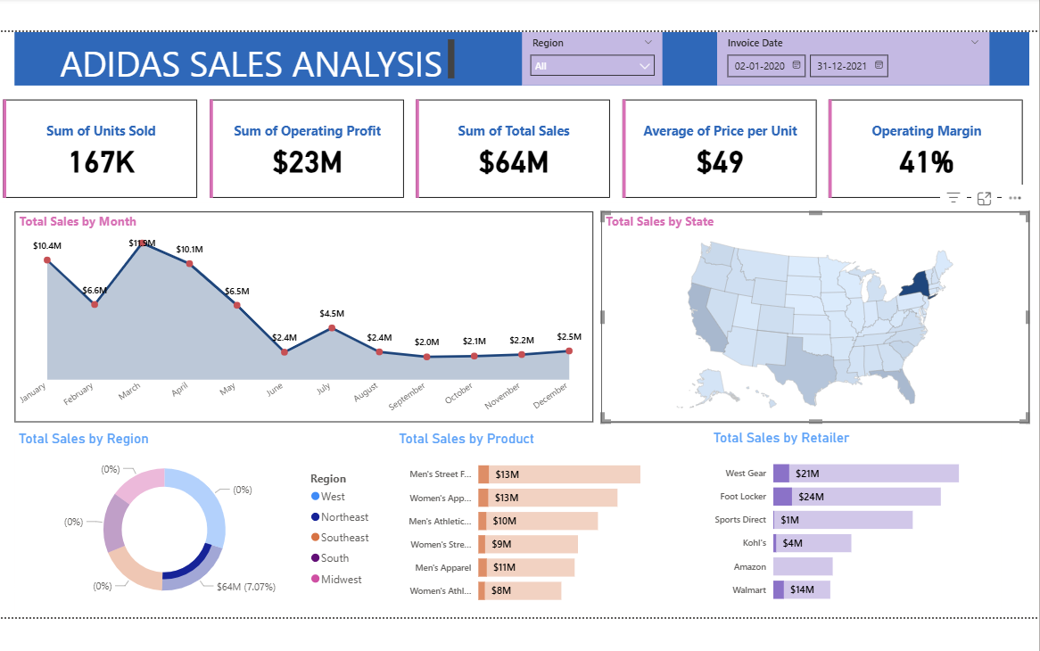

Fig 2 : ADIDAS SALES ANALYSIS STATE WISE VISUALIZATION

CONCLUSION

The Adidas Sales Analysis Dashboard project successfully demonstrates how raw retail transaction data can be transformed into meaningful, interactive, and insightful visualizations using Power BI. By integrating sales data across multiple regions, retailers, product categories, and time periods, the system provides a comprehensive view of both individual sales channel performance and overall business health, enabling efficient analysis without the need for complex manual calculations.
The project effectively achieves its objectives by delivering an intuitive dashboard that highlights key metrics such as total sales of $899M, operating profit of $332M, 2 million units sold, an average price of $45 per unit, and a 42% operating margin. Features like region-based filtering, dynamic date range selection, and interactive cross-filtering between the choropleth map, donut chart, line chart, and bar charts enhance the user experience and allow deeper exploration of sales data. The identification of top-performing retailers (West Gear, Foot Locker) and product categories (Men's Street Footwear) further adds value to strategic business decision-making.
From a technical perspective, the use of Power Query for data preprocessing, data modeling for structured relationships between sales, retailer, product, and region tables, and DAX for advanced financial calculations ensures accuracy, consistency, and performance efficiency. The system is scalable and can be easily updated with new quarterly or annual Adidas sales data, making it suitable for continuous business monitoring and analysis.
In conclusion, this project bridges the gap between raw Adidas retail data and actionable sales insights, making data analysis more accessible and effective for sales managers, regional heads, and business executives alike. It highlights the power of modern data visualization tools in simplifying complex datasets and supports better understanding, comparison, and decision-making in the context of retail sales performance analytics.

REFERENCES

- Microsoft Power BI Documentation https://learn.microsoft.com/en-us/power-bi/ (Reference for Power BI features, DAX functions, and data modeling techniques)
- DAX Guide https://dax.guide/ (Used for understanding and implementing DAX formulas for financial sales calculations)
- Power Query Documentation (M Language) https://learn.microsoft.com/en-us/power-query/ (Reference for data transformation and preprocessing of Adidas sales transaction records)
- Kaggle – Adidas Sales Datasets https://www.kaggle.com (Used for structured datasets containing Adidas US retail sales and transaction records)
- Towards Data Science – Power BI Tutorials https://towardsdatascience.com (Reference for best practices in data visualization and sales dashboard design)
- Tableau & Data Visualization Concepts (General Reference) https://www.tableau.com/learn/articles/data-visualization (Used for understanding best practices in data visualization for retail sales analytics)
- VTU Official Website https://vtu.ac.in (Reference for academic structure, project guidelines, and report submission requirements)

